Process Management

Ps aux

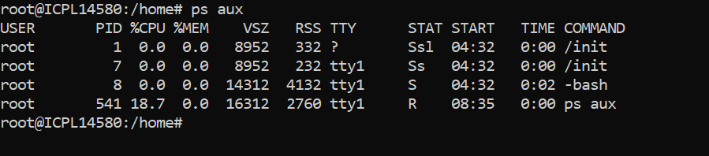

Ps –e

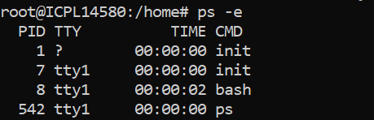

Ps –f



Ps –ef

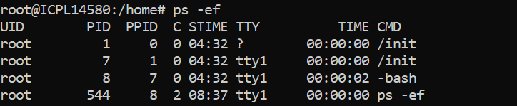

Ps aux | grep processName



How can you display hierarchical information about parent and child processes

using ps ?

Use the ps --forest option (or --ppid for specific parent PIDs):

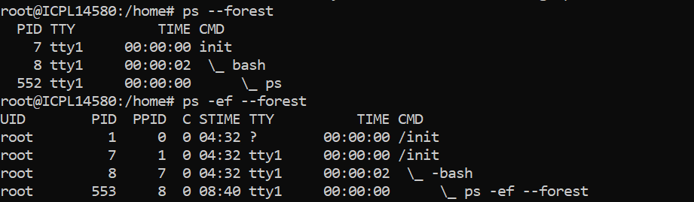

Top and htop

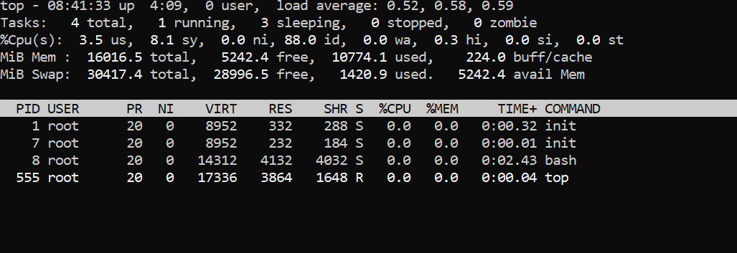

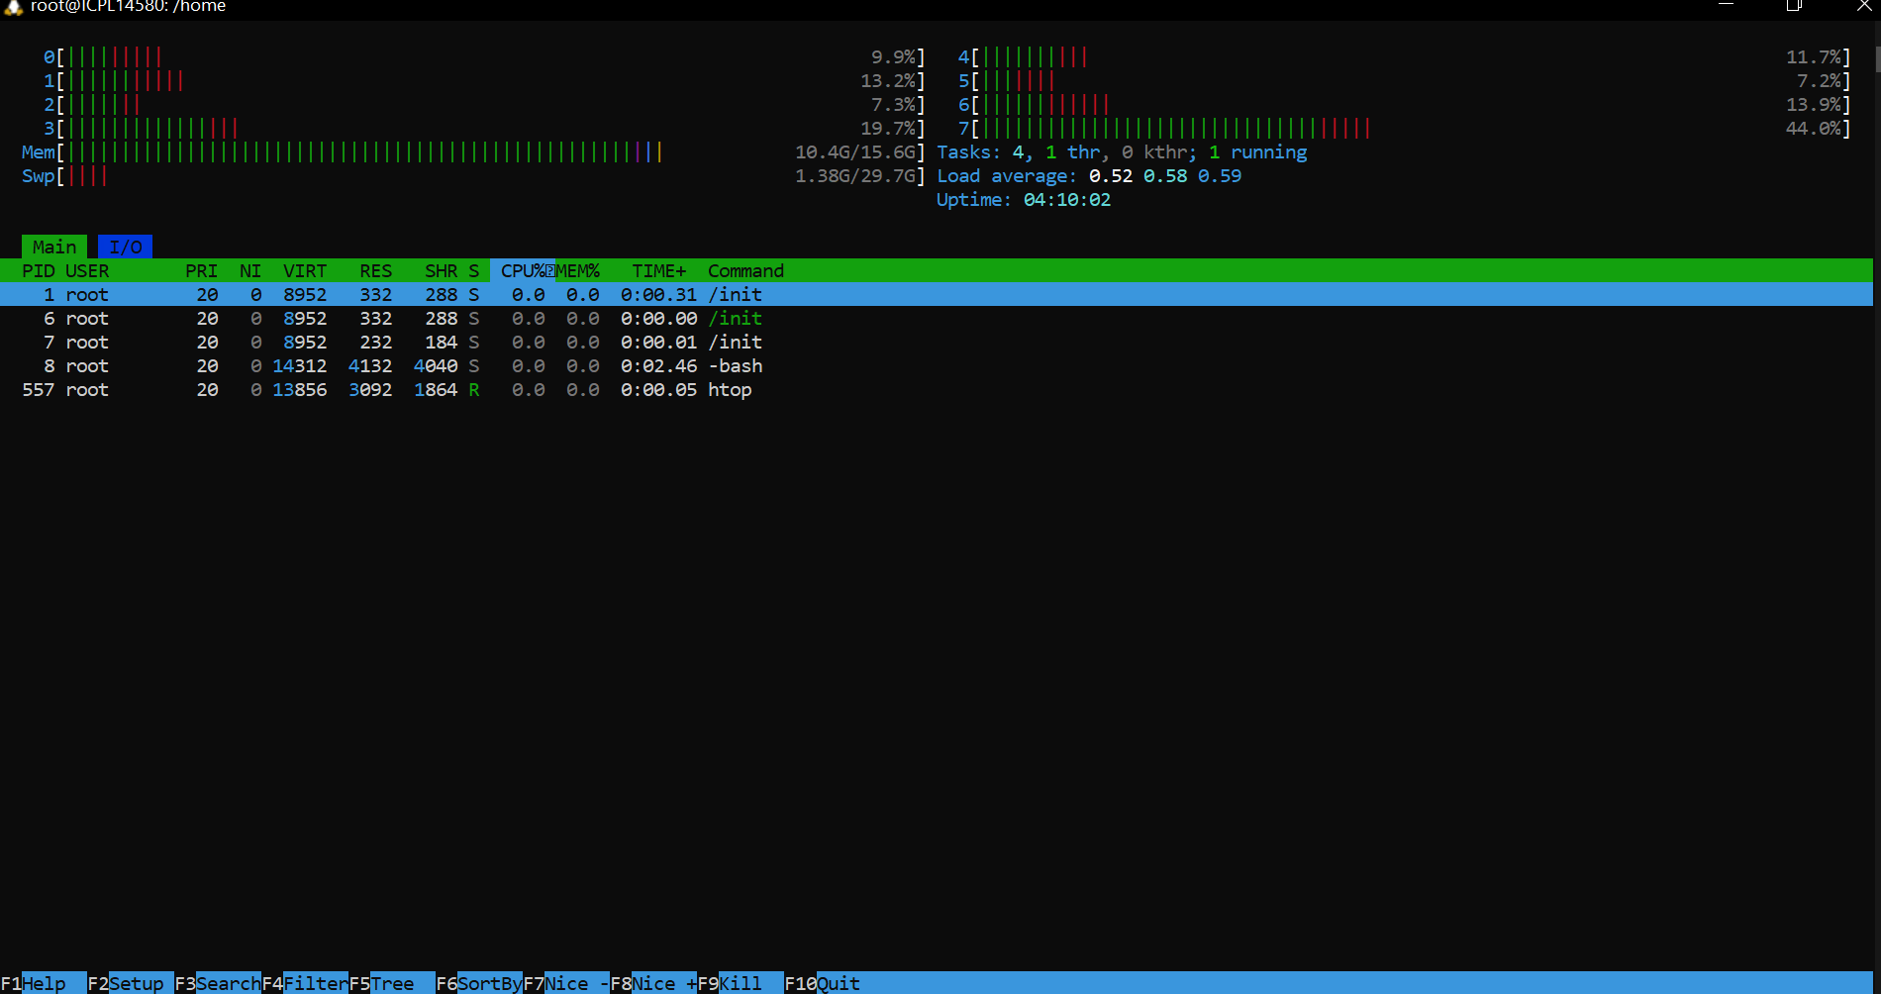

Top –u username

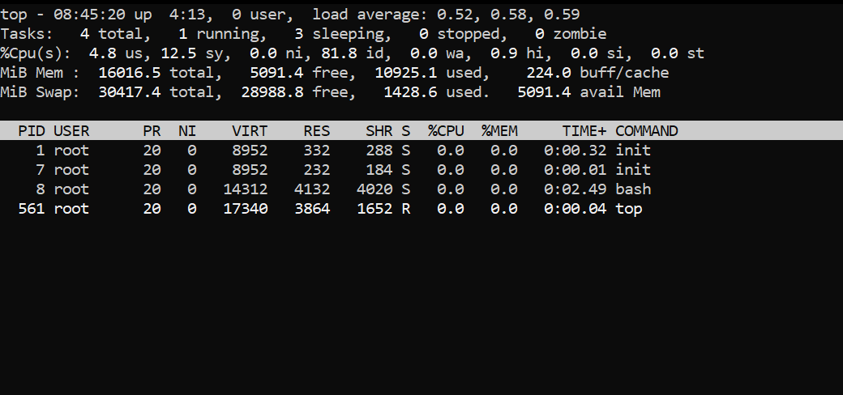

Load average: 1.02, 0.85, 0.77

Uptime

Load average indicates the average number of processes waiting to run over the last 1,

5, and 15 minutes.

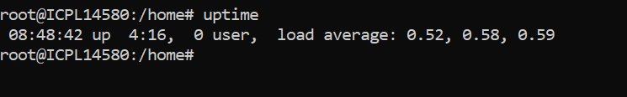

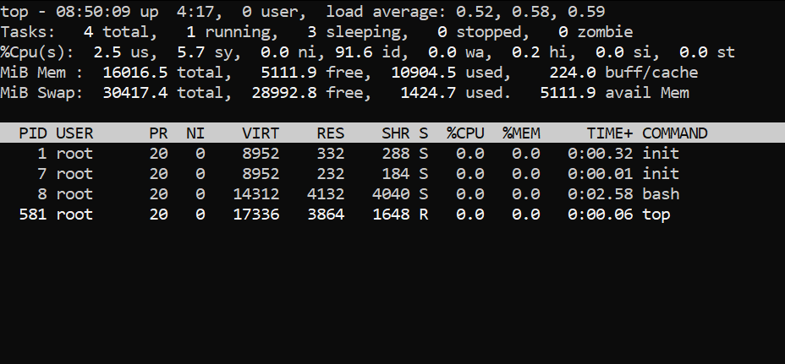

How can you kill a process directly from htop ?

Highlight the process using arrow keys and press F9 to kill it.

Created dummy process using sleep command and killed it using f9 command using htop

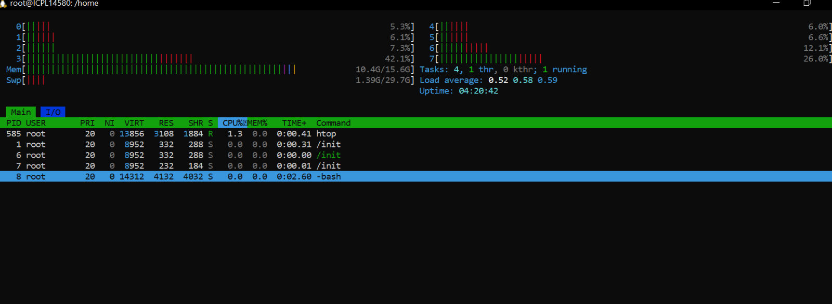

Kill command

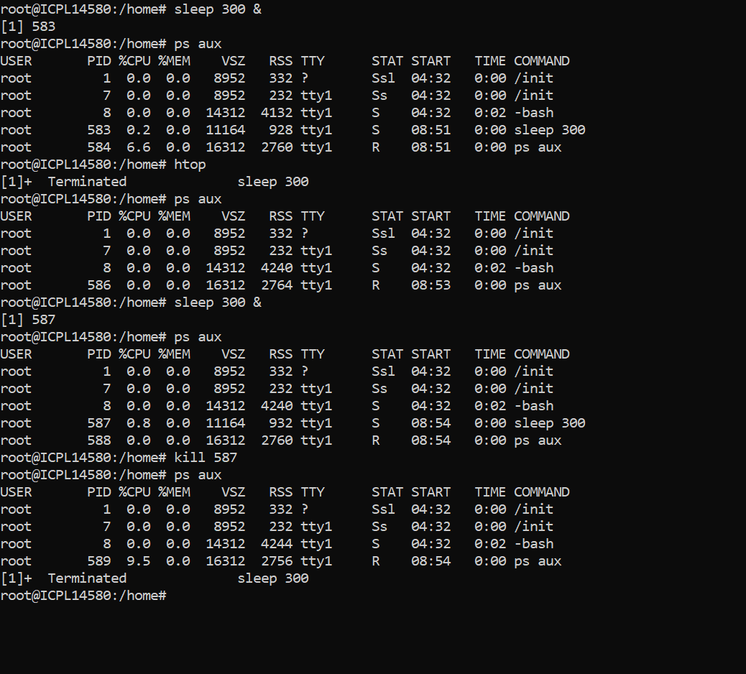

kill -9 : Sends a SIGKILL signal to forcefully terminate the process.

kill -15 : Sends a SIGTERM signal, allowing the process to exit gracefully

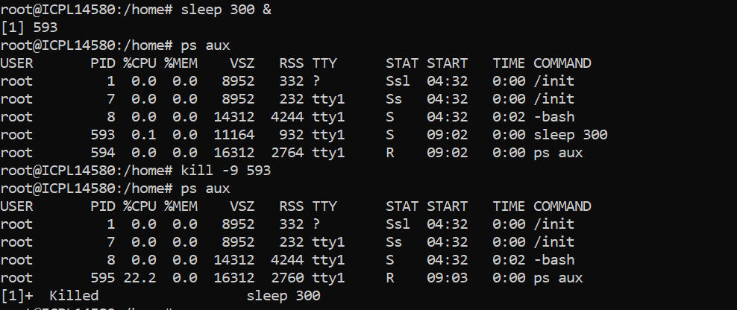

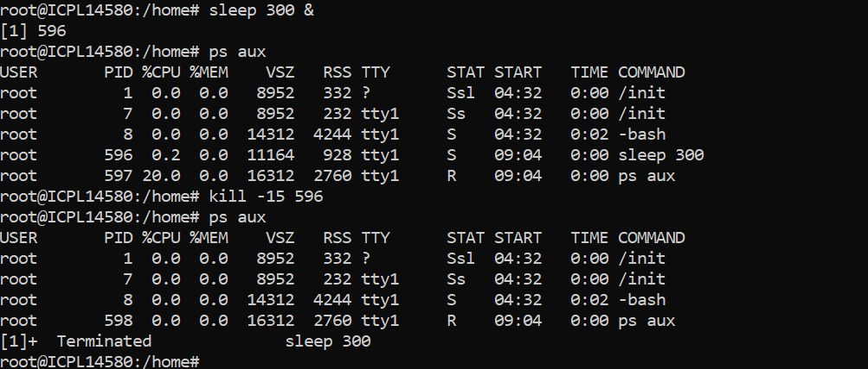

pkill : Kills processes by name.

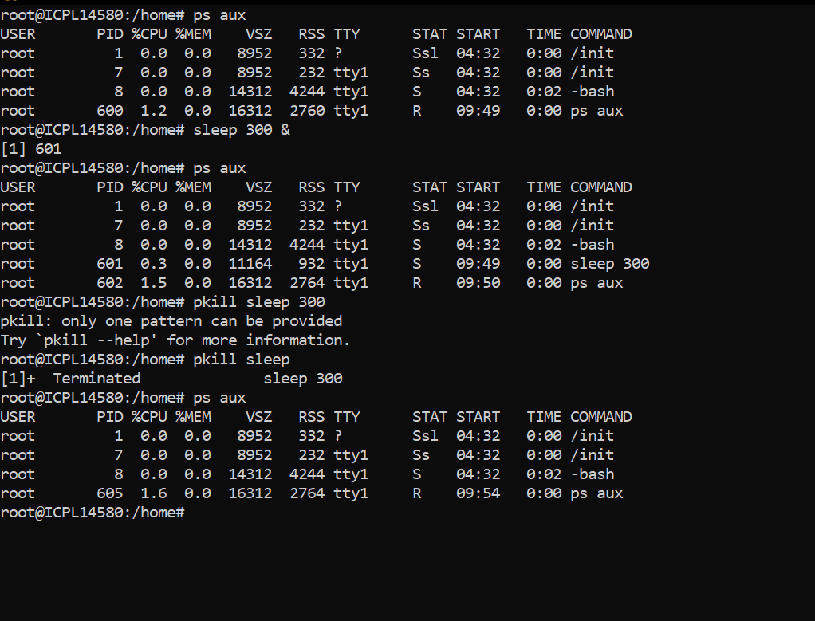

kill : Requires specifying the PID.

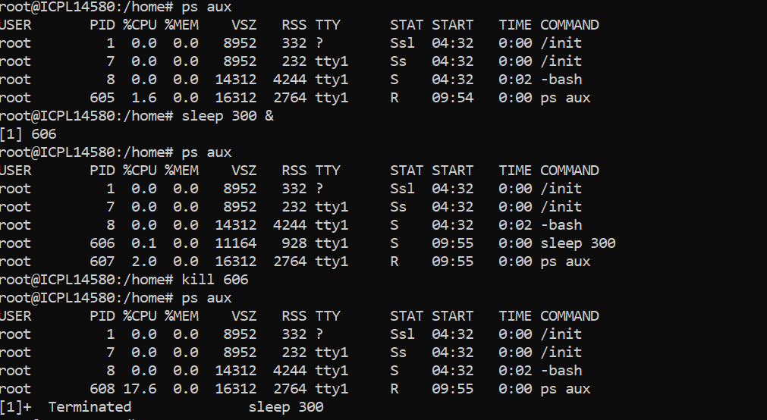

pkill -u username process_name

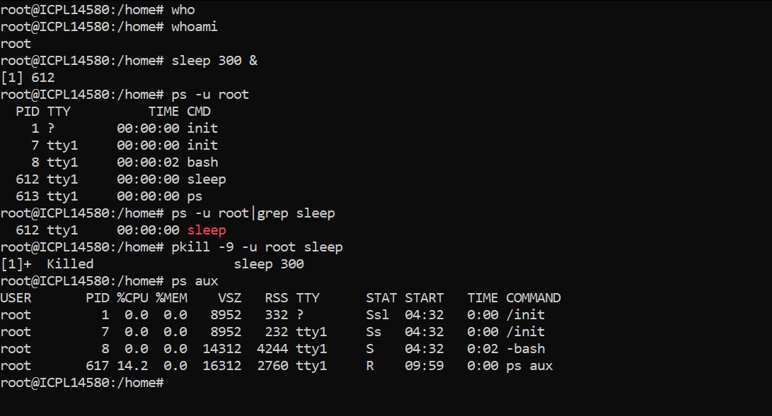

pkill -SIGHUP process_name

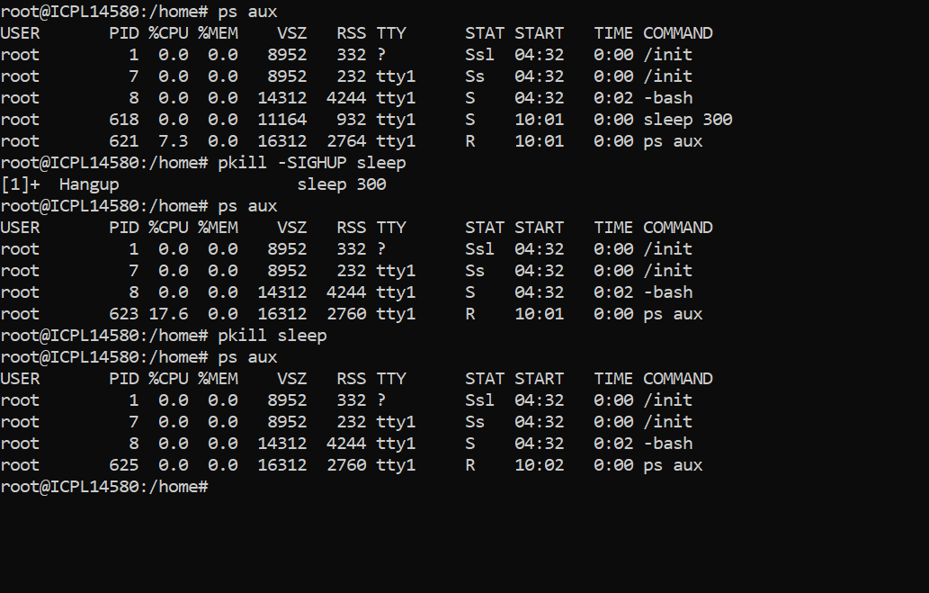

Nice and renice values for priority

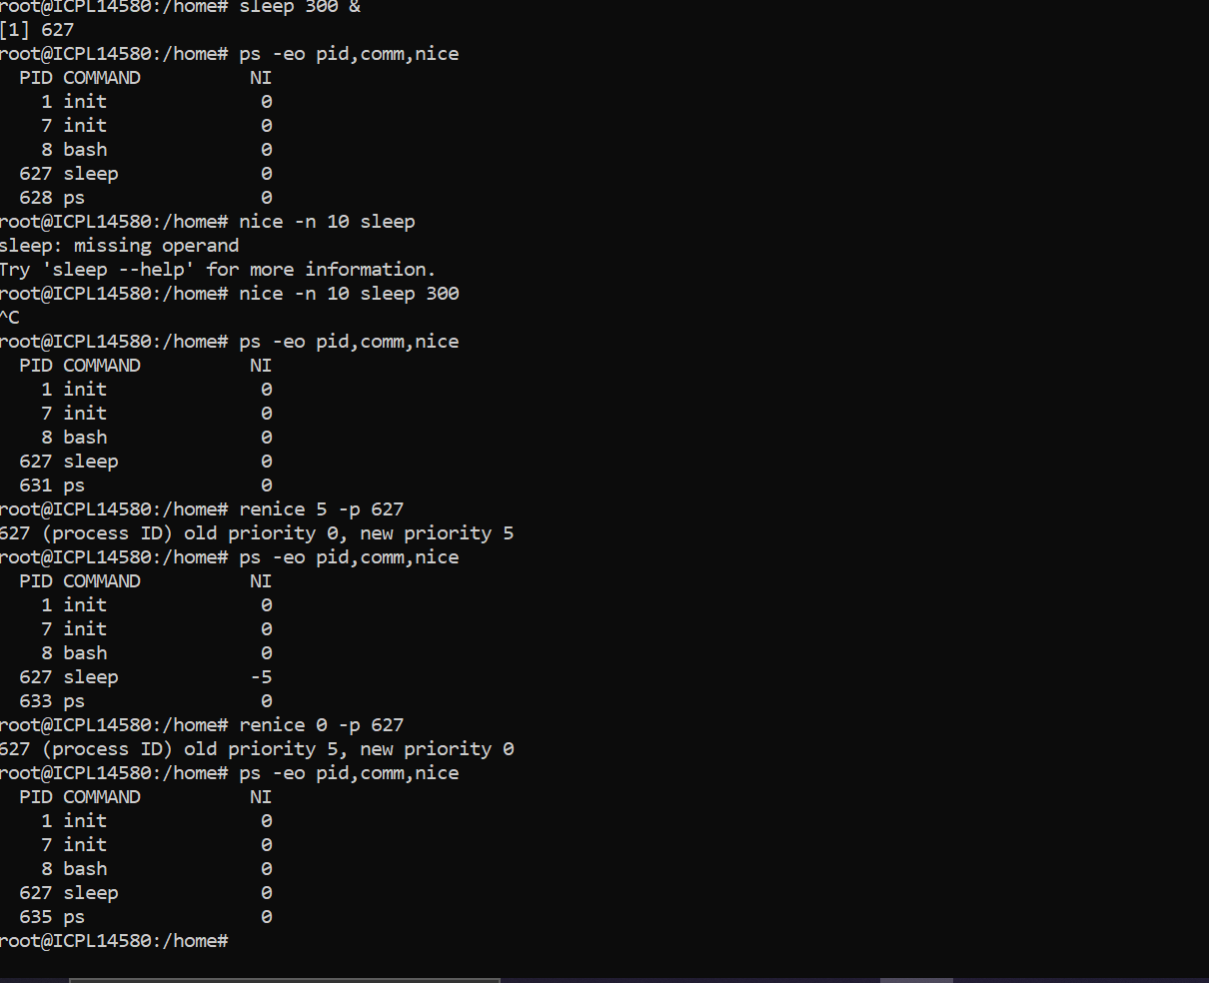

Ps –l

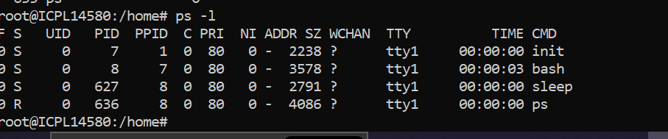

nohup my_program &

nohup my_program > my_output.log &

